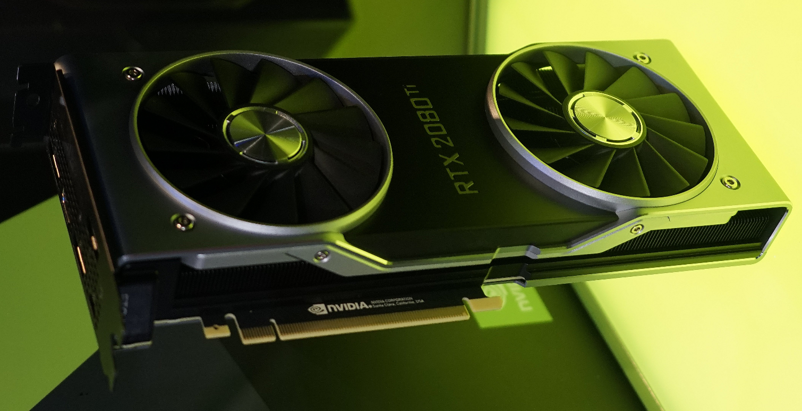
Nvidia’s new Turing-based GeForce RTX GPUs are pricey, and enthusiast gamers have taken notice.
Unsurprisingly, consumers have some passionate responses to these prices. They are calling for more competition from AMD, wondering if the performance benefit is worth it and saying they just won’t buy right now.
The main promise of these new cards is ray tracing, which is a rendering technique that results in real-time light reflections and cinematic effects that can make games look a lot more like movies.
So, why are Nvidia's new Turing cards so expensive? Nvidia didn’t respond to questions about why the cards are pricey.

